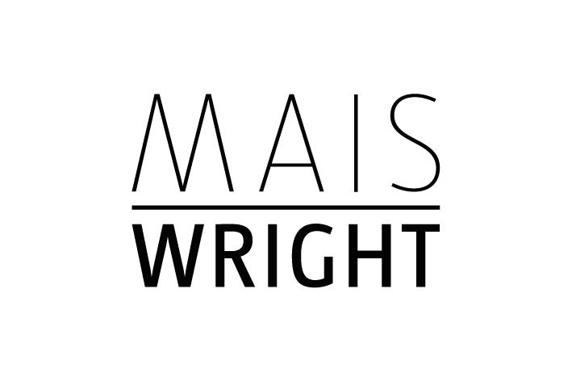

**TOM LOVEDAY**

Tom Loveday is a contemporary artist living in Sydney. His practice includes painting, video, performance, installation and curatorial projects. Loveday’s art practice is influenced by post-war European *emigré* artists as well as global contemporary art. His main focus in painting is colour and geometry with works ranging from op-art influence to hard-edged geometric abstraction. Detailed images and information can be found at https://tom-loveday.squarespace.com/

Loveday studied art at North Adelaide School of Art in the 1980s and began exhibiting in Adelaide in 1988. achieving both a Masters by Research in painting and PhD in painting at Sydney College of the Arts in the 2000s. He has taught architecture, visual art, art history and supervised higher degrees by research (HDRs) at leading universities including University of Technology, Sydney, University of NSW, and University of Sydney.

Loveday has also been a registered architect, having studied and practised in South Australia in the 1980s and early 1990s and was a musician in the 1970s and currently also writes art theory and philosophy, https://sydney.academia.edu/TomLoveday. He also produces soundscapes and music at https://soundcloud.com/user-374435368. Tom also exhibits regularly in independent and public galleries, is a member of Modern Art Projects Blue Mountains, and his work is held in a number of private collections both nationally and internationally including Artbank Australia.

**ACADEMIC QUALIFICATIONS**

• 2006 Doctor of Philosophy (PhD), Theories of art practice/painting, Sydney College of the Arts, University of Sydney

• 2001 Master of Visual Art (MVA) Painting, by research (studio project), Sydney College of the Arts, University of Sydney

• 1986 Bachelor of Architecture (BArch) Louis Laybourne Smith School of Architecture and Building, South Australian Institute of Technology (now University of South Australia)

• 2013 Foundations of Postgraduate Research Supervision Workshop, University of Sydney.

• 2006 PhD Supervision Workshop,Human Resources Unit, University of NSW

**SOLO EXHIBITIONS**

• 2021 *Over the Edge,* KRONENBERG MAIS WRIGHT, Sydney Australia,

• 2018 *The Edge of Reality,* KRONENBERG MAIS WRIGHT Sydney .

• 2017 *Erotic Painting,* Conny Dietzschold Gallery,Sydney

• 2015 *Infrathin: Advice for Aliens*, Wollongong Art Gallery, Wollongong.

• 2014 *The Planets*, Conny Dietzschold Gallery, Sydney

• 2013 *Healing Colour, The Edge of the World,* Conny Dietzschold Gallery, Sydney,

• 2012 *The Planets: Reviewed*, Australia Catholic University, Sydney.

• 2011 *Textworks,* Peleton Gallery, Sydney

• 2009 *Memorial*, Dominik Mersch Gallery, Sydney,

• 2005 *The Planets,* University of Sydney, Sydney College of the Arts, Sydney

• *2004 Flat*, University of Sydney, Sydney College of the Arts, Sydney

• *2004 The Planets*, Sydney College of the Arts, University of Sydney, Sydney.

**GROUP EXHIBITIONS**

• 2022 *LUMIERE,*, Modern Art Projects Blue Mountains (MAPBM),

• 2021 *SQUARE 2,* Five Walls Projects, Melbourne,   
*•* 2020 *Séance* – Fade to Black, Stanley Street Gallery, Sydney   
**•** 2020 *Blue*, Blue Mountains Cultural Centre, 2020, Modern Arts Projects, Blue Mountains.   
• 2019 *SQUARE*, May Space, Sydney.

• 2019 “Mapping,” Modern Art Projects, Blue Mountains, Braemar Gallery,

Springwood

• 2019 “*Future Abstract,”* for VIVID Sydney, Art Space, Chatswood,

• 2019 “The Tenacious Realm,” Willoughby Visual Arts Biennial, Sydney Tom Loveday. *Willoughby Train*

• 2018 “*Imperceptible Resistances,”* Modern Art Projects, Blue Mountains, Everglades Gallery, Leura,

• *2018 Colour Run,* Braemar Gallery, Springwood, .

• *2018 Zombie Painting,* Stacks Gallery, Sydney,.

• *2018 Ferret 4,* Articulate Project Space, Sydney,

• 2018 *GROUP* exhibition KRONENBERG MAIS WRIGHT , Sydney.

• *2017 Chromotopia*, Tacit Gallery, Melbourne,

• *2016 Group exhibition*, Kronenberg Wright Artists Projects, Sydney

• *2016 The Small Format,* Conny Dietzschold Gallery, Sydney

• *2016 Incandescence*, Grace Cossington Smith Gallery,Sydney.

• *2015 Grace Cossington Smith Art Prize,* Grace Cossington Smith Gallery, Sydney

• *2015 Painting 1, Edge, Angle, Grid*, William Wright Artists Projects, Sydney

• *2015 Magenta*, Modern Art Projects, Blue Mountains

• *2014 reSATURATEryb*, Grace Cossington Smith Gallery, Sydney,

• *2014 From a Near Future*, Sydney College of the Arts, Staff Exhibition, SCA Galleries, Sydney,

• *2014 Conversation*, A-M Gallery Sydney, collaborative exhibition with Lisa Jones

• *2014 Di Colori*, William Wright Art Project, Sydney

• *2013 APT Open Studio Exhibition*, Deptford London, UK

• *2012 Re-enactment 1: Karawane*, The Reading Room, in *Recycled Dreaming*, at The Drawing Room, Sydney

• *2012 Saturate (Alchemy),* Sydney College of the Arts, University of Sydney, Sydney

• *2012 Re-expanded/Re-extended Painting,* MOP Projects, Sydney

• *2011 Textworks 2,* Artereal Gallery, Sydney.

• *2010 The Stranger’s Eye*, Peloton Gallery, Sydney

• *2010 Emergency Display*, At the Vanishing Point Gallery, Sydney

• *2010 Living Space*, At the Vanishing Point Gallery, Sydney

• *2010 Rocking the Boat*, At the Vanishing Point Gallery, Sydney

• *2009 The Real World*, At The Vanishing Point Gallery, Sydney

• *2009 Smartlight,* group exhibition, University of Technology Sydney,

• *2009 StarGazing,* group exhibition, At The Vanishing Point Gallery, Sydney

• *2008 Ambiguosity,* At The Vanishing Point Gallery, Sydney

• *2008 From Mao to Now,* Sydney Olympic Park, Sydney

• *2007 Echelon*, Peloton Galleries, Sydney.

• *2007 Is it getting hotter in here,* At The Vanishing Point Gallery, Sydney

• *2007 Tactile imagination,* Ivan Dougherty Gallery, University of New South Wales, Sydney,

• *2005 Bleak epiphanies,* Virginia Wilson Gallery, Sydney.

• *2004 Postgraduate research student graduation exhibition,* Sydney College of the Arts

• *2003 Ethos*, IDEA , Sydney.

• *2002 Dark spaces*, exhibition with Halinka Orszulok ,Tin Sheds Gallery, University of Sydney

• *2002 Measured Drawing*, Masterclass, University of South Australia, Adelaide

• *2001 Master of Visual Arts*, Graduate exhibition, Sydney College of the Arts, University of Sydney,

• *2001 PGR*, at Newspace. Sydney College of the Arts.

• *2000 Techné*, UTS Gallery, Faculty Gallery,

• *2000 Balmain public sculpture project*, SCA, Sydney

• *1998 Red*, Global Gallery, Sydney

• *1998 Loveday Dutkiewicz Seelander*, PCL Exhibitionists, Sydney

• *1997 Colour, form and the illusion of space*, UTS Gallery, Sydney.

• *1995 On Albion Street*, Albion Street Gallery, Sydney,

• *1995 The easy life*, Albion Street Gallery, Sydney, life drawing and painting.

• *1995 Artist's choice*, Albion Street Gallery, Sydney, .

• *1994 It isn't easy being green*, Albion Street Gallery Sydney.

• 1994 Royal South Australian Society of Arts, 75th Anniversary Exhibition, Adelaide

• 1994 Royal South Australian Society of Arts, Autumn Exhibition Adelaide,

• 1994 Royal South Australian Society of Arts, Spring Exhibition, Adelaide

• 1988 Adelaide Festival Fringe, Rundle Street Gallery, Adelaide

**AWARDS**

• 2011, Blake Prize Finalist.

• 2015, Grace Cossington Smith Art Prize Finalist*,* Grace Cossington Smith Gallery.

• 1993, seven times winner, Royal South Australian Society of Arts Award of Merit from the Board of Directors (Fellows) for contributions to seasonal exhibitions.

**COLLECTIONS**

• Artbank Australia

• Pat Corrigan Collection

• Private Collections in Australia, Germany, UK and America